**Training and Attestation**

**Purpose**

The purpose of this document is to identify the training objectives completed, specific tasks completed, and attest that I completed the exercises utilizing my own understanding of the material.

**Exercise 2.9.2**

**Core**

1. Verify the default router configuration.
   1. Establish a console connection to R1.
   2. Enter privileged exec mode and examine configuration.
2. Configure and verify the initial router.
   1. Configure R1:
      1. Hostname.
      2. MoTD.
      3. Encrypt all plaint text passwords.
      4. Setup passwords for privileged exec mode and console password.
   2. Verify the configuration.
3. Save the running configuration.

**Screenshots of Completion**

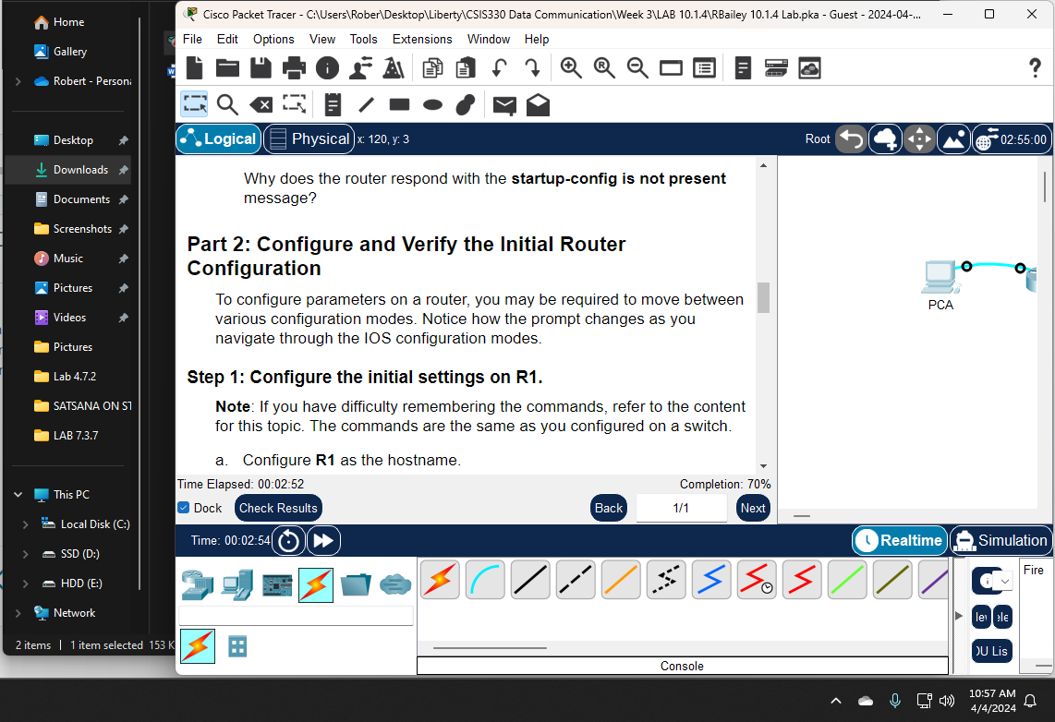

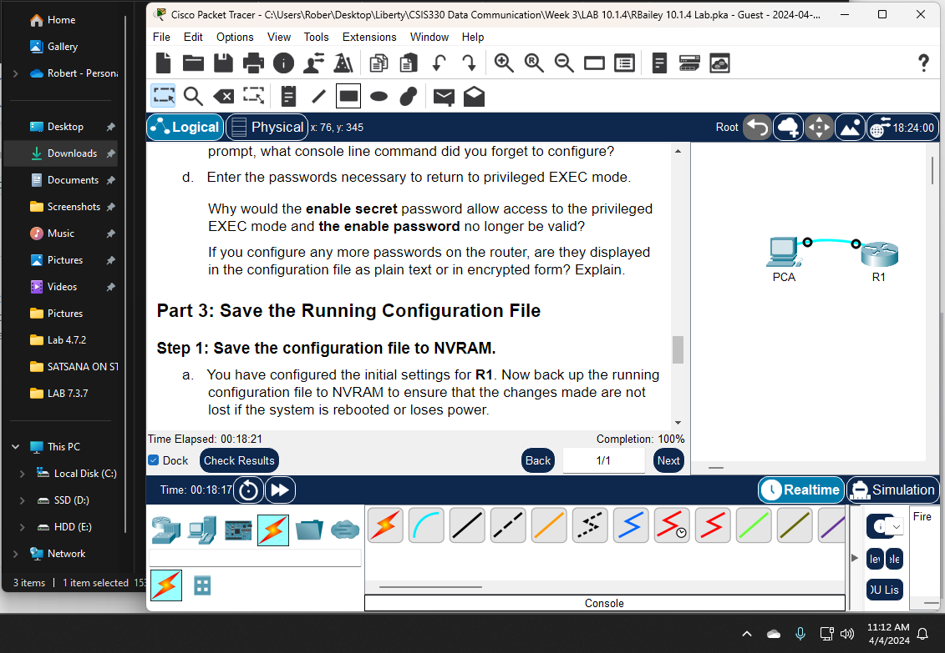

**Attestation**

I certify that I completed all the work required for this lab using the skills and knowledge gained from completing the Liberty University course work and Official Cisco CCNA training material. The answers were my own and I did not plagiarize anyone else’s work.

